CHM112 PROTOCOL-16th February 2016

Quantitative determination of total hardness of water by complexometric EDTA titration.

The total hardness of water is defined by the content of calcium and magnesium combined.

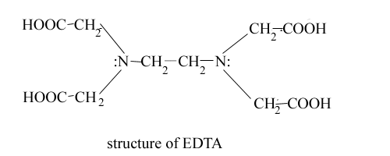

The reaction of this experiment are:

2H2Y2- + Ca2+ + Mg2+ ⟶ CaY2- + MgY2- + 4H+

H2Y2- + MgIn- ⟶ MgY2- + HIn2- + H+

Color change: wine red to clear blue

Reagents provided:

EDTA

Calcium carbonate

Metallochrome EBT indicator

Distilled water

Ammonia-ammonium chloride buffer (pH 10)

Unknown water

1. Preparation of standard CaCO3 solution for the standardization of EDTA:
2. Dissolve CaCO3 in distilled water and add little HCl slowly drop wise to dissolute it.
3. Standardisation of EDTA:
4. Take 10 mL of calcium carbonate solution and add 75 mL distilled water to it in a 250 mL conical flask.
5. Add 3mL of the ammonia ammonium chloride buffer to it.
6. Also add 15 drops of EBT indicator and titrate against the unknown EDTA solution.
7. Record the reading of the volume and repeat this 3 times.

Calculate the molarity of the EDTA.

1. Determination of the strength of calcium and magnesium ions present in the water:
2. Take 50mL of unknown mixture in a 250 mL conical flask and to it, add 3 mL buffer and 10 drops of the indicator.
3. Titrate against the known EDTA solution.
4. Repeat this experiment for 3 times.

Calculate the molarity of the unknown mixture.

Calculate the hardness of the water in mg/L.